Recent Contributions to the Understanding of the Heart Mountain Detachment, Wyoming

David H. Malone, Dept. of Geography-Geology, Illinois State
University, Campus Box 4400, Normal, IL 61790
dhmalon@ilstu.edu

and

John P. Craddock, Geology Dept., Macalester College, St. Paul, MN 55105 Craddock@Macalester.edu

ABSTRACT
For more than a century, the Heart Mountain Detachment has attracted the attention of researchers and students from around the world. The development of the continuous allochthon model for Heart Mountain Faulting about 20 years ago as an alternative to the long-standing concept of Tectonic denudation has provided the context for the latest generation of work on the origin and emplacement of allochthonous upper plate rocks.
The consensus of work in the last 15 years indicates that volcanic rocks overlying the HMD are everywhere allochthonous. The upper plate was emplaced catastrophically (>150 m/sec) through the collapse of a volcanic edifice in the northern Absaroka Range at about 49.5 Ma. In the proximal areas of the Detachment, vent facies volcanic rocks were down-dropped and translated to the SE. During the edifice collapse, the underlying sheet of Paleozoic rocks was dismembered, and the various blocks were rotated independently around a vertical axes of rotation. To the southeast, in the adjacent Big Horn and Absaroka Basins, the upper plate was emplaced upon an Eocene land surface. Here, the upper plate has the characteristics of a large debris avalanche deposit, which is similar to those that are found at the base of younger stratovolcanoes around the world. Several 100 km to the south, in the Green River Basin, where lacustrine conditions dominated, the effect of the emplacement of the upper plate was evidenced by a significant dessication event as the upper plate damned drainage upstream.
Prior to collapse, active hydrothermal systems were present at several volcanic centers. The collapse was initiated by the injection of volcanic gas and glass, and the heating of pore waters through volcanic intrusion, which caused the reduction of friction that enable the mass of rock to move. Continued movement (i.e. friction reduction) was facilitated by mechanical fluidization and the frictional dissociation of carbonate rocks and the consequent generation of CO_{2.} Thus, the idea of a gravitational collapse of the continuous allochthon, and the catastrophic emplacement rates required of tectonic denudation, are best supported by the available data.

INTRODUCTION
The Heart Mountain Detachment in northwest Wyoming has been the focus intense geologic research for more than a century. Literally dozens of papers, maps and conference presentations authored by scores of scientists of diverse backgrounds have been published on the Heart Mountain problem over the years. Despite this level of attention, many of the aspects of the geometry, origin, and deformational history of the Heart Mountain Detachment remain problematic and controversial. Hauge (1993) provides an excellent summary of the general characteristics of the Heart Mountain Detachment; he also provides a detailed review of the history of research and an insightful historical discussion of the important points of controversy. Readers are strongly encouraged to read this important paper as this is the basis for the summary presented herein. The most recent field guide for the Heart Mountain Detachment area is provided by Malone and others (1999).
At Heart Mountain, just north of Cody, Wyoming, the more than 230 m of Paleozoic limestone and dolomite beds that form the summit overlie with no apparent discordance early Eocene and older, pre-Laramide strata. Heart Mountain is an erosional remnant of a much more extensive upper plate the Heart Mountain Detachment (Figure 1). The major characteristics of the Heart Mountain Detachment (HMD) as summarized by Hauge (1993) and Malone (2000) are: 1) an extended (>3400 km² in area) upper plate with transported distances of as much as 50 km; 2) a detachment horizon in the proximal areas that consistently occurs along a lower Ordovician bedding plane; 3) an average dip of the detachment horizon at the time of emplacement of less than 2º; 4) a breakaway, bedding plane, and ramp components, with a younger-over-older age relation in the proximal areas area and an older-over-younger age relation in the distal areas. Part of the upper plate, at least the distal toe, most likely was transported over an Eocene land surface; and 5) a maximum time frame for emplacement of <2.0 Ma during middle Eocene time, and perhaps as little as 0.2 Ma.

Tectonic Denudation vs. Continuous Allochthon
Two fundamentally different models describing the geometry, kinematic pattern, and emplacement of the upper plate of the HMD were described by Hauge (1993). For many years, the upper plate was viewed to have been emplaced catastrophically as numerous independent slide blocks (Figure 2a; Pierce 1973, 1987), and as a result of this detachment faulting, a tectonically denuded surface was formed. Immediately after faulting had ceased, massive outpourings of Wapiti Formation volcanic rocks were deposited on the detached blocks as well as on the tectonically denuded surface (Pierce 1973, 1987). The most compelling line of evidence for this interpretation is the complete lack of erosion on the exposed fault plane, indicating that the time interval between slide block emplacement and the deposition of the Wapiti Formation must have been very short.
During the 1980s, a different model for the emplacement of the HMD upper plate was advanced. In this view, the upper plate is interpreted to have been a continuous allochthon rather than a series of individual slide blocks (Figure 2b; Hauge 1985, 1990, 1993). Volcanic rocks overlying the detachment, originally viewed as in depositional contact, were reinterpreted as allochthonous, and as such comprising much of the upper plate (Hauge 1990). Thus, the continuous allochthon model requires no tectonic denudation or catastrophic emplacement of numerous slide blocks, and the model eliminates the mechanical enigma that tectonic denudation poses.
It is important to note that the tectonic denudation model was developed initially in the distal areas of the detachment, before the existence and geologic characteristics of the proximal areas were discovered. Conversely the continuous allochthon model was developed from work that was almost exclusive to the proximal areas, that is along the break-away and bedding plane areas of the Detachment.

Dominant Problem, Circa 1993
Hauge (1993) reported the following dominant problems at the time of his writing: What is the structure and stratigraphy of Eocene volcanic rocks overlying the detachment? Are they in depositional contact, or are they allochthonous? If allochthonous, what mechanism transported them to their present position, and what does that relationship reveal about the emplacement mechanism, kinematic pattern and emplacement rate of the upper plate?
The purpose of this report is to summarize the contributions of the current generation of works to the understanding of the Heart Mountain Detachment. Eighteen peer-reviewed papers that address various aspects of the Heart Mountain problem have been published between 1993 and 2008. More than thirty conference presentations, three PhD dissertations, one MS thesis, and more than a dozen BS research projects, largely through Keck supported efforts in the late 1990s also have been completed. In the sections that follow, we will focus mainly on the peer reviewed publications.

DISCUSSION
Stratigraphy of Eocene Volcanic Rocks
As indicated by Hauge (1993), the key to understanding the dynamics of the emplacement of the upper plate of the HMD rests squarely on further study of the associated Eocene volcanic rocks of the Absaroka Volcanic Supergroup (see Sundell, 1990 for a detailed overview of these rocks). Unfortunately, because of the abundance of vent facies rocks, the local intense deformation of these rocks, and the generally poor exposure and access, no viable and widely accepted volcanic stratigraphy has ever been established in the proximal areas of the HMD. Hauge (1990, 1993) recommended that the units defined by Pierce (i.e. the Wapiti and Cathedral Cliffs Formation) be abandoned, and that general or informal terminology be used instead. No significant progress has been made to the understanding of the stratigraphy of Eocene volcanic rocks in the proximal areas of the HMD.

Further to the south, in the distal areas of the HMD and beyond, vent facies rocks grade into epiclastic volcanic rocks, where defining a working, valid stratigraphy is possible. As part of his PhD research, Malone conducted detailed stratigraphic studies and geologic mapping at a scale of 1:24,000 was carried out in a 250 mi² (650 km²) area in the North and South Fork Shoshone River valleys in the northeastern Absaroka Range, an area roughly corresponding with the former-land-surface phase of the Heart Mountain detachment as defined by Pierce (1987). Figure 3 is a composite stratigraphic column for volcanic rocks that occur in this area. Here described blocks (individually as large as several km² in area) of vent-medial-facies lava flows, breccias, and sandstones within a thin, heterogeneous matrix of boulder- to sand-sized volcaniclastic material are observed (Figure 4). The blocks and matrix together comprise a laterally continuous and mappable lithostratigraphic unit within the volcanic succession. He designated this unit the Deer Creek Member of the Wapiti Formation. Further work by Malone (1997) indicated that the unit also occurs throughout the upper South Fork Shoshone River valley.
The Deer Creek Member is interpreted as the deposit of a debris avalanche, formed by the collapse of a large stratovolcano within the northern Absaroka Range during the early middle Eocene time. The currently documented areal extent and volume of the Deer Creek Member are ~175 mi² (450 km²) and ~24 mi³ (80 km³), respectively. These numbers are similar to younger debris-avalanche deposits reported in many Quaternary volcanic successions. The Deer Creek Member is temporally and spatially associated with allochthonous Paleozoic Rocks of the Heart Mountain Detachment. Initially, Malone (1994) advocated a two-stage retrogressive collapse of a volcanic edifice in the Sunlight Peak area. Later work by Beutner and Craven (1996) indicated that the Crandall intrusive center was a more likely source area for this collapse, Malone (2003) and Rhodes and others (2007) argued for a single collapse with the Eocene volcanic and Paleozoic carbonate rocks that comprise the Deer Creek member represent the distal toe and debris-avalanche deposit that resulted from the edifice collapse.

Timing of Emplacement
In the early 1990s, the best estimate for the timing of the emplacement of the upper plate of the HMD was based on vertebrate paleontology of Willwood and Wapiti Formation rocks at the base of Jim Mountain. Stratigraphic evidence from Eocene sedimentary and volcanic rocks (Pierce 1973, 1987; Torres and Gingerich 1983) indicates that the emplacement of the upper plate of the HMD occurred within a 2 million year window during the early middle Eocene (49.5-47.5 million years ago). This 2 million year window enabled Hauge (1985, 1990) the time needed for slow, gravity spreading of a continuous allochthon.
Feeley and Cosca (2003) provide an excellent summary of the petrology, geochemistry, and geochronology of the Sunlight Peak vent complex at Jim Mountain (Figure 5). The timing of Heart Mountain faulting is now well constrained in the distal areas of the HMD where upper plate rocks overlay Eocene strata of the Willwood formation. Feeley and Cosca (2003) report an ⁴⁰Ar/³⁹Ar age of 49.5 ± 0.16 Ma for basal Jim Mountain lava at Jim Mountain, which is about 100 m above the Heart Mountain interval. Based on paleontological evidence in the North Fork Shoshone River Valley (Torres 1985: Gunnell and others 1992), Heart Mountain faulting must have occurred during the earliest middle Eocene (Bridgerian age, Blacksforkian subage; North American Land Mammal Age) between 50-49 Ma. Figure 5 illustrates these age relationships at Jim Mountain.
Heart Mountain faulting correlates with a major dessication horizon in the Laney Member. Rhodes and others (2007) recognized mudcracks as much as 2 m deep superimposed on lacustrine mudstones of the lower LaClede Bed of the Green River Formation in the Washakie Basin. These mudcracks reflect a sudden and intense desiccation of Eocene Lake Gosiute. In a related study of Eocene stratigraphy of Wyoming, Smith et al. (2003) reported ⁴⁰Ar/³⁹Ar weighted mean ages of tuffs overlying and underlying the dessication horizon to be 49.70 ± 0.10 and 48.94 ± 0.12 Ma, respectively, which correlates well with the timing of the Heart Mountain event further to the north. Thus, Rhodes and others (2007) proposed a unique cause-effect relationship, where the emplacement of the upper plate caused the drainage to Lake Gosiute to be impounded, which resulted in the reduction of the water supply to the lake and the development of the large mud cracks.
Based on the geochronologic evidence provided by Feeley and Cosca (2003) and Smith and others (2003), the time interval for Heart Mountain faulting has been reduced by an order of magnitude. Assuming a maximum error in the reported geochronologic data the time frame for Heart Mountain faulting is 49.34-49.80 Ma. Assuming all reported dates are reliable, Heart Mountain faulting would have had to have occurred between 49.70 and 49.50 Ma, which leaves 200 Ka as the time available for faulting and the deposition of some overlying and underlying rocks. A catastrophic emplacement of the upper plate is therefore likely.
New absolute ages are available in the proximal areas of the HMD as well. Near the break-away area, Douglas et al. (2003) report ⁴⁰Ar-³⁹Ar ages on a variety of small plutons between 48.1 ± 0.5 to 50.1 ± 0.3 Ma, within the age range of HMD tectonism.
In an abstract, Hiza (1999) reported an age of 48.21 ± 0.08 ka on a deformed dike (presumably transported as part of the upper plate), but noted that the field relations were ambiguous at that locality. Furthermore she reported and age of 50.01 ± 0.14 for an undeformed tuff that overlies the breakaway (presumably from the Trout Peak Trachyandesite). This age would seem a bit old, as all other work suggests younger ages for rocks overlying the HMD upper plate. In any case, Hiza advocated that this data supported the protracted deformation associated with the Continuous Allochthon Model.
In an abstract, Beutner and others (2004) reports two ⁴⁰Ar-³⁹Ar ages of 48.34 and 48.59 Ma from rootless plutons in the upper plate (no location or errors given). If these plutons are indeed allochthonous, this would suggest an emplacement event at least a million years later than what is indicated to the south. Assuming such, the upper plate would need to have been emplaced sequentially as multiple events.

Emplacement Rate of the Upper Plate
Observations from the Detachment Breccia
Aside from Eocene volcanic rocks, the “breccias” along the detachment horizon have received the lion’s share of attention over the past 15 years as clues about the initiation and transport mechanisms of the upper plate were sought. What has been described as “detachment breccia” is composed largely of carbonate material up to 1-2 m in thickness, which occurs at the base of the upper plate at most localities in the proximal areas of the HMD (Pierce 1973; Beutner and Gerbi, 2005). Because lower plate rocks are undeformed, this breccia was interpreted by Pierce (1973, 1979) to have been derived from the upper plate as a “tectonic carpet” during its emplacement. Because little or no volcanic material was originally found in this breccia where it is overlain by volcanic rocks, Pierce (1973, 1987) argued that these volcanic rocks were deposited after emplacement of the upper plate and a period of tectonic denudation. In a number of areas, this breccia intrudes upper plate rocks as clastic dikes Pierce (1979). In addition to the all-carbonate breccia, breccia of mixed-volcanic carbonate and all-volcanic (Hauge 1985) compositions have been reported. Hauge (1985) reported lineations (interpreted as fault striae with kinematic significance) at most exposures, and used the term microbreccia to describe these rocks.
Beutner and Craven (1996) and Beutner and Gerbi (2005) reported the occurrence of accreted, rolled and mantled grains, volcanic and delicate glass shards within the microbreccia at White Mountain and many other localities within the HMD region (Figure 6a-c). The glassy grains are variable in composition, may contain phenocrysts, and have shard-like shapes and cuspate margins. The presence of glass indicates that a volcanic event was intimately associated with the development of the detachment breccias, and that the injection of a “sill like mass of volcanic gasses, glass, and finely broken carbonates” initiated the catastrophic movement of the upper plate.
The accreted grains typically have a central core of volcanic or carbonate rock, which are armored by concentric rims that are as much as a mm in thickness. These accreted grains bear a strong resemblance to accretionary lapilli in volcanic settings and impact sites. Buetner and Gerbi (2005) interpret these accreted grains as being formed in some type of gaseous suspension, and that the gas was derived through dissociation of carbonate through frictional heating during catastrophic emplacement of the upper plate. These volcanic and friction derived fluids contributed to the mechanism that enabled the upper plate to move down such a gentle slope.
Anders and others (2000) examined the bottoms of many large slide blocks, including the breccias of the HMD, and found layers of well rounded, coarse grained, granular material which bears a strong resemblance to fluvial sandstones or conglomerate. They believe that these fabrics were formed through mechanical sieving in a high energy, fluidized environment during catastrophic emplacement of the upper plate.
Investigations of the HMD at White Mountain have redefined the “breccia” as a carbonate ultracataclasite (CUC; Craddock and others, In Press). This one meter thick unit is well-lithified (“welded”) and composed of calcite, dolomite, aragonite and lizardite, has a density of 3.01 gm/cc and a melting temperature of 1330°C. Geochemically, the CUC is 7.5% SiO₂, something confirmed by the presence of volcanic fragments and mafic minerals (e.g., hornblende) and the contemporaneous nature of volcanism to faulting along the HMD. We also observed calcite and quartz (and combinations of both) spheroids (100 micron diameter melt droplets?), and a variety of zeolite minerals as reaction rims. Some components of the CUC were in liquid form as the HMD became active (volcanic source?), and some underwent phase changes during faulting, and fluids were present during faulting. Anisotropy of magnetic susceptibility (AMS) measurements preserve a clean magnetic fabric with the long axis (K_{max}) of the magnetic ellipsoid parallel to the upper plate transport direction. Similarly, paleomagnetic results confirm magnetite as the primary magnetic carrier mineral (Curie T° 580°) and as the palemagnetic paleopole is down and westward, and not up and southerly as would be expected for the Eocene, the CUC rocks are remagnetized.

Calcite Twinning Strain
Craddock and others (2000) conducted a detailed analysis of calcite twining strain fabrics in upper and lower plate carbonate rocks in order to better understand the emplacement rate and kinematic pattern of the HMD event. Lower plate rocks revealed an E-W shortening axis that formed during the Laramide Orogeny. No post-Laramide strain overprint was observed in upper or lower plate rocks. As twinning is a strain-rate dependent process, the absence of any twinning strain overprint indicates that the emplacement of the upper plate was likely catastrophic.

Physical Constraints and Mechanical Modeling
Craddock and others (In Press) were the first to objectively quantify the emplacement rate of the upper plate. They offer thermodynamic and mechanical calculations based on frictional melting of calcite and other minerals, geochemical data, and the characteristics of the HMD breccias at White Mountain. This calculation reveals an upper plate emplacement rate of 126-340 m/sec and that the duration of the emplacement event was on the order of a few minutes, too brief a time to develop an emplacement-related calcite twinning strain overprint in upper or lower plate carbonates. This brief and catastrophic detachment event produced a significant amount of CO₂ by flash heating.

Detachment Fluids
Templeton and others (1995) reported systematic C and O isotope depletions from the break-away fault to the ramp. They interpreted that hot meteoric waters, generated by Eocene intrusive centers circulated along the HMD during the gradual emplacement of a continuous allochthon, and thus supported Hauge’s model. One major flaw in this study is that only allochthonous carbonate rocks were analyzed. No data is reported from associated volcanic rocks. Furthermore, no data was collected from nearby autochthonous rocks west of the break away or at Beartooth Butte.
Douglas and others (2003) expanded the isotopic data set of Templeton and others (1995) and included some isotopic dates (mentioned above) and fluid inclusion data. They noted that isotopic depletions were more significant near the break-away, and that the fluids were associated with hydrothermal activity at the New World Mining district north of Silver Gate. Thus, although it is clear that a fluid phase did indeed interact with the rocks above and below the HMD horizon, these fluids may have circulated here before, through intrusion fluid interaction, during through frictional heating during upper plate emplacement, or after movement using the newly formed, high porosity fault zone as a pathway (Aharanov and Anders, 2006).

Detachment Kinematics
Eocene Dikes at Cathedral Cliffs
One extensional mechanism of Hauge’s continuous allochthon is the intrusion of an igneous dike swarm that he interpreted to be coeval with faulting, and thus accommodate part of the dilation of the upper plate. These dikes are spectacularly exposed at Cathedral Cliffs (Figure 7), where dozens of dikes pervade allochthonous Paleozoic rocks. DeFrates and others (2006) analyzed the magnetic fabrics of 32 mafic dikes at Cathedral Cliffs using low-field anisotropy of magnetic susceptibility (AMS) as a proxy for flow. These dikes intrude Ordovician-Mississippian carbonate and overlying Eocene volcanic rocks and are truncated along the nearly horizontal HMD. The dikes trend between N10°W and N20°E, are all steeply dipping, and range in width between 0.5 to 3 m. Flow directions for the dikes were determined by the bearing and plunge of the K_{max} (maximum principal susceptibility) axes relative to the dike orientation. About 70% of the dikes sampled show typical dike AMS patterns with K_{max} and K_{int} in the plane of the dike and K_{min} normal to the dike plane. As no dikes exist locally in the lower plate, the most reasonable explanation for these dikes is that they are older than, and unrelated to, Heart Mountain faulting, and are thus not kinematically related to the emplacement of the upper plate. The roots of the dikes studied here are likely buried beneath younger volcanic rocks northwest or west of Cathedral Cliffs. It is possible and perhaps likely that dike intrusion occurred immediately prior to the emplacement of the upper plate, and that volcanic processes were involved in the emplacement event.
Hot Water
Aharanov and Anders (2006) proposed that the diking at Cathedral Cliffs and elsewhere in the area was essential to the initial movement of the upper plate. In their view, extensive dike intrusion into the upper plate before faulting created a special condition that allowed horizontal stresses to increase, and thus contributed to elevated pore fluid pressures in the basal Bighorn Dolomite. Simultaneously, the heating caused by the diking event caused the trapped pore waters to expand. These high pore fluid pressures caused the reduction in normal stress needed for initial movement. Once movement was initiated, other mechanisms (i.e. volcanic injection, mechanical fluidization, etc.) could have contributed to continued movement of the upper plate.

Calcite Twinning Strain
Footwall limestones preserve a layer-parallel shortening strain normal to the subduction margin of North America and maintain this E-W orientation in their original depositional position. Upper plate Madison Limestones preserve this same layer-parallel shortening strain but, as the upper plate blocks are allochthonous, the orientation of the shortening axes is quite varied (Figure 8) thereby documenting the chaotic downslope motion of limestone blocks (Craddock and others 2000). Many of the blocks rotated about vertical axis as they slid down the detachment. At White Mountain the upper plate marbles have a layer-parallel shortening axis oriented at 203° that constrains the block rotation to be either 113° counterclockwise or 247° clockwise, as compared to the 90° layer-parallel shortening strain in the footwall limestones. We do not have a means to know if there was one rotation or many. White Mountain preserves striations on the detachment that are oriented at 154° so the upper plate block was already rotated as it slid to rest toward 154°. White Mountain is so named because the upper plate rocks are Madison Group limestones that are now marbles; both the marbles and detachment-parallel calcite veins record a vertical shortening strain that is likely the result of post-HMD burial (Craddock et al, In Press).

SUMMARY
The fate of tectonic denudation
The sum of all research over the past 15 years overwhelmingly indicates that Eocene volcanic rocks overlying the HMD are everywhere allochthonous. Also, the preponderance of the evidence suggests that these rocks were emplaced catastrophically during the collapse of part or all of one or more volcanic edifices in the northern Absaroka Range. Thus, the interpretations by Pierce and his colleagues at the U.S. Geological Survey that were developed in the 1960s-1980s of independently emplaced blocks via gravity sliding has attracted little attention by the current generation of workers. Pierce’s model of catastrophic emplacement, albeit of a continuous allochthon or large landslide/debris avalanche, has however, been supported by most of the recent work.

The fate of the continuous allochthon
Much of the work done over the past 15 years was stimulated by Hauge’s continuous allochthon model, and many of the various aspects of the model were rigorously tested. His idea of all volcanic rocks overlying the HMD being allochthonous rather than being in depositional contact thus far has stood the test of time. Furthermore, all workers today agree that the upper plate was emplaced as part of an intact sheet that was comprised of Paleozoic and volcanic rocks. His observations of faults within upper plate rocks, brecciated lower plate rocks, and lineations along the fault plane have gone unchallenged.
His interpretation of the rate of emplacement, and the kinematics of extension have however been challenged, and the new data that is now available requires modification to the continuous allochthon model. There is now ample subjective and objective evidence that suggest that the upper plate was emplaced catastrophically rather than gradually. Also, volcanic processes, both directly and indirectly, likely led to the initiation of the upper plate, and its continued movement down a gentle slope. Rather than gravity spreading associated with a building volcanic pile, workers today envision the emplacement event as the collapse of a one or more existing volcanic edifices.
How then, can the great many faults described by Hauge (1985) be explained? Certainly, some of these faults could have formed during the catastrophic collapse. Others could have formed prior to the collapse during an earlier episode of gravity spreading (see Beutner and others 2004). Finally, some could have formed after the collapse event during a later phase of gravitational collapse (see Malone 1994 for a discussion of some normal faults near Logan Mountain).

Semantics and Research Context Issues
The Heart Mountain Detachment is enigmatic, complex, well studied, controversial, and unfortunately still poorly understood. In our view, a major part of the problem here is the enormous volume of literature from a variety of sub-disciplines within geology that has been produced over the years. Such a volume makes it very difficult to write simple, short paper that will honor all of the past research. Similarly, this large amount of work has resulted in at least two different contexts in which the present generation of workers is operating; this makes it very difficult and in some cases impossible for these workers to communicate. For example, some workers (e.g. Hauge) view the HMD purely in the context of structural geology. In the context of structural geology, deformed volcanic and Paleozoic rocks are allochthonous and part of an upper plate. The boundaries between components of the upper plate are faults. The lower contact of allochthonous rocks is everywhere a detachment. Relief on the detachment in the distal areas is interpreted to be attributed to footwall and side wall ramps. Figure 9 is a photograph of the Detachment at Jim Smith Creek, which is in the proximal areas of the HMD. Here the contact is razor sharp. Hauge (1985) reported brecciated volcanic and Paleozoic rocks along the detachment, an igneous dike that terminates on the HMD, and a striated microbreccia just above the contact. Here, volcanic rocks are allochthonous in the traditional sense, and they were downfaulted and translated during the emplacement of the upper plate.
A second context is to view the allochthonous rocks in a geomorphic/stratigraphic context. For example, at Mount St Helens, there is a body of rocks on the north side of the mountain that has a distinct lower contact with some relief, covers a several 10 km², is more than 100 m in thickness in places, consists of blocks and matrix, has a hummocky upper surface, was observed to be associated with an eruption and blocked the drainage of a river system. We can easily call this a debris-avalanche deposit because the debris avalanche that formed the deposit was observed as it was emplaced in 1981. A similar body of sediment and rock exists at the base of a number of volcanic edifices around the world. These can comfortably be called debris-avalanche deposits as well, even though the debris avalanche was not observed, it was inferred, which is uniformitarianism in the most simple form. If a body of rock of similar texture, thickness, structure, composition, areal extent, etc. as part of an Eocene volcanic succession in Wyoming, this geomorphic/stratigraphic context could still apply. The geomorphic/stratigraphic context is the basis for the work of Malone, Sundell, Anders, and Craddock. In this context, the body of allochthonous Paleozoic and Eocence rocks in the distal regions of the HMD as a lithostratigraphic unit within the Eocence volcanic succession of the Absaroka Range. Instead of fault-bounded blocks, these are blocks separated by matrix. Some blocks are volcanic, some are limestone. Some are big (>10 km across), some are small. The basal contact is an unconformity, which is a sedimentary rather than tectonic contact. Figure 10 provides a photograph and geologic map of the Bear Creek area on the southwest side of Sheep Mountain. Figure 11 is a cartoon that illustrates the issue of where or not the basal contact in the distal areas of the HMD
Thus, is there a fundamental difference between a catastrophically emplaced extensional allochthon and a large landslide/debris avalanche?
Future workers are advised to use appropriate, non-genetic terminology as possible, and should appreciate that a feature as large and complex as the Heart Mountain Detachment requires input from many subdisciplines of geology.

Did the upper plate override an Eocene land surface?
One question that has arose since the advent of the continuous allochthon model concerns whether or not the upper plate emplaced onto a land surface in its distal areas (south and west). Another way to couch this question is: Is the basal contact of the upper plate in the distal areas of the HMD a fault, unconformity, or some sort of hybrid? In the proximal areas of the HMD, the answer to this question is clear, and all workers refer to the contact as a fault. In the distal areas of the HMD (i.e. south and east of Rattlesnake and Pat O’Hara Mountains), the answer to this question is more ambiguous, and dependent on the context of how the upper plate is considered.
Pierce (1957, 1975) in the development of the Tectonic Denudation model for Heart Mountain faulting, interpreted that upper plate of the HMD was emplaced upon an Eocene land surface, and that adjacent/overlying volcanic rocks were later deposited on this same land surface. Hauge (1985, 1990) argues that the upper plate of the HMD may not have transgressed an Eocene land surface. He recommended that the term former-land-surface be avoided, and the descriptive term “detachment ramp” to be used instead. Based on structural and stratigraphic data gathered during my research and earlier investigations by other workers, there is ample evidence that an Eocene land surface did indeed exist, and that this land surface was overridden by allochthonous Paleozoic and volcanic rocks. These lines of evidence include:
1) Sundell (1990) reports the existence of a regional unconformity at the base of the volcanic succession throughout the Absaroka Range. The entire Eocene succession was deposited in a wide range of terrestrial (i.e. Willwood Formation), volcanogenic environments (i.e. AVS units), and consequently, numerous breaks in deposition (unconformities) must exist. The contact at the base of the DCM represents a sharp contrast is sedimentation. The Willwood Formation consists of basin-fill sandstones and mudstones, and the Wapiti Formation consists of volcanogenic strata, thus a break in deposition must occur between these two successions.
2) There is a younger over older age relationship beneath all volcanic rocks in the distal areas of the Detachment. If the volcanic and carbonate rocks were indeed emplaced together as part of the same catastrophic event, this age relationship is more consistent with an unconformity rather than a fault.
3) Petrified wood is present in the matrix of the DCM, suggesting that a forest was overridden and that debris from this forest was incorporated during the emplacement of the debris avalanche.
4) The complex local relief on the lower surface is more likely to be the result of fluvial-geomorphic rather than structural processes (Malone, 1996, 1997).
5) Elsewhere in the eastern Absaroka Range, as much as 300 m of distal facies volcanic rocks (the lower stratified and tuff breccia members of the Wapiti Formation of Malone, 1996 and 1997) occur between the DCM and underlying Willwood Formation. These rocks are absent where DCM rests directly upon the Willwood Formation and older units. The absence of these older volcanic rocks requires erosion and/or no deposition of volcanic strata prior to the emplacement of the DCM, thus indicating an unconformity.
6) If this contact were some sort of a low-angle fault that did not “daylight” and where the upper plate did not transgress a sizeable land surface which includes a number of foot wall ramps, there would need to be an identical number of hanging wall (upper plate) ramps in order to construct a viable and admissible cross section, according to thin-skin geometric theory. Furthermore, the entire Mississippian-Eocene section that is present within the footwall ramp would need to be found in the hanging wall somewhere. A few small blocks of the Willwood formation are present, much less than a fraction of a percent of the entire upper plate, but there are no rocks in the upper plate between the age of Mississippian and Eocene. The simplest explanation is that these rocks never existed in the upper plate and that they were removed by erosion during the Laramide Orogeny rather than first being incorporated in the upper plate, transported to the Big Horn Basin, and then eroded away since Eocene time without a trace. To take this a step further, it is even simpler to state that a hanging wall ramp never existed at all, and the pre-faulting situation included an erosional surface to the south and east of the footwall ramp.
7) A few small fragments, some more than 100 m in maximum dimension, of the Willwood Formation occur at structurally high positions within the DCM (Malone 1996). The simplest explanation for these enigmatic features is that they were incorporated from the underlying strata, perhaps small hilltops, during emplacement of the DCM.
Based on the above lines of evidence, it is almost certain that the distal toe of the allochthon did indeed cross an Eocene land surface during emplacement, as originally envisioned by Pierce (1973).
Summary of the Emplacement of the Upper Plate
Most workers over the past 15 years agree that the best explanation now for the emplacement of the upper plate of the HMD is some sort of catastrophic gravitational collapse of part of the Absaroka volcanic pile about 50 million years ago (e.g. Malone 1994, 1995, 1996, 2000; Buetner and Craven, 1996; Beutner and Gerbi, 2005, Aharanov and Anders, 2006; Craddock and others, 2000, In press). In light of this work, the following is proposed sequence of events for tectonism along the Heart Mountain fault (please compare with Malone, 1996, Figure 25 and Beutner and Gerbi, 2005, Figure 16).
1) Prior to Absaroka volcanism, Laramide tectonism created the surrounding structural features including the Beartooth Uplift, Pat O'Hara and Rattlesnake Mountain anticlines, and the Absaroka and Big Horn basins (Figure 12, Figure 13a). Uplift of the anticline features was coincident with the deposition of Willwood Formation sandstones and mudstones in the adjacent basins. The boundary between the Beartooth Uplift to the north and the Absaroka Basin to the south is structurally complex and probably consisted of two northwest-trending fault/monocline systems, each displaying several thousand feet of structural relief. The northern fault zone is the Clarks Fork fault system, and the southern fault zone is buried beneath younger volcanic rocks, but is probably along strike with the Pat O’Hara Mountain anticline. The evidence for this southern fault/monocline is clearly indicated by the sub volcanic rocks that occur within the region. To the north, in the Clark’s Fork drainage, the sub-volcanic rocks are everywhere Paleozoic in age. In the Shoshone River drainage west of Rattlesnake Mountain >25 km to the south, the sub volcanic rocks are everywhere Mesozoic and Tertiary in age (Malone 1996, 1997). A major structural discontinuity with several thousand meters of relief is needed to account for these field relations. A buried Laramide fault zone/monocline is the simplest explanation for this structural discontinuity.
Between these two Laramide fault zones, Paleozoic rocks dip gently off of the Beartooth Uplift to the south and southeast. These rocks comprise most of the future bedding plane and ramp phases of the HMD.
2) The waning stage of Laramide tectonism was accompanied by the inception of igneous activity in the Absaroka Volcanic Province. In the northern Absaroka Range, several large stratovolcanoes developed likely in the vicinity of the younger New World, Crandall, and Sunlight vent complexes. Relief between the tops of the volcanoes and the basin floors at this time, and throughout Absaroka volcanism, probably exceeded 20,000 ft (6230 m). To the south, in the present Shoshone River valleys, basinal conditions persisted, and the Absaroka Basin was filled with more than 1000 ft (300 m) of light-colored distal-facies sandstones, mudstones, and conglomerates.
3) Ongoing tectonism during the waning stages of the Laramide orogeny, active erosion of along the toe of the volcanic pile, the rapid deposition of loosely consolidated volcaniclastic material, and volcanic-plutonic-hydrothermal activity in the Absaroka Range created an unstable gravitational situation for the region.
4) The injection of volcanic gas and glass (Beutner and Gerbi, 2005; Douglass and others 2003) and/or the reduction of normal stress through igneous diking and the consequent heating of pore fluids, cause the initial movement of the upper plate. The upper plate contained volcanic rocks, Paleozoic rocks, and many small intrusions.
5) Initial and subsequent movement was catastrophic, with the entire event taking less than an hour. This catastrophic movement along the HMD created significant frictional heat, which caused the dissociation of CO₂ and development of the unique textures and structures found in the detachment breccia (Anders and others, 2000, Beutner and Craven, 2005; Craddock and others, In Press). The presence of this supercritical fluid reduced friction, and enabled the upper plate to be emplaced along a gentle slope. Mechanical fluidization described by Anders and others (2000) and other workers may have aided in the mobility of the upper plate (Figure 13b).
6) The proximal areas of the HMD are dominated by vent facies volcanic rocks. These rocks were down-faulted during the emplacement event. The geometry and kinematics described by Hauge may still apply, but at a faster rate that he proposed. In the distal areas of the HMD, the upper plate was emplaced onto an Eocene land surface as a gigantic debris-avalanche that contained both carbonate and volcanic components. The Rattlesnake Mountain/Pat O’Hara Mountain structures served as a wedge, funneling some of the debris avalanche to the east into the Big Horn Basin, and some to the South into the Absaroka Basin. The debris avalanche came to a rest once fluidization dissipated. The debris avalanche dammed the paleodrainage system, causing dessication in Lake Gosuite, several hundred km to the south.
7) After emplacement, minor gravitational adjustments occurred, and eventually volcanism resumed, burying the upper plate. Eventually, the upper plate was dissected by stream erosion, leaving remnants resistant rocks (e.g. Heart Mountain; Figure 13b).

Recommendations for the next phase of research
During the past 15 years, significant advancements have been made to the understanding of the emplacement of the upper plate of the HMD. The stragraphy of volcanic rocks, at least in the distal areas of the HMD, the timing of movement, the rate of upper plate movement, the kinematic pattern of the upper plate, and the mechanism for fluidization are better understood now than ever before. However, many significant problems remain:
- In light of the available geochronology data, is the emplacement of the upper plate better explained as a single event, or are multiple events required?
- Where was the volcanic edifice that collapsed?
- Can the emplacement rate of the upper plate at White Mountain as determined by Craddock and others (In Press) be supported by similar calculations elsewhere?
- Can a viable volcanic stratigraphy be developed in the proximal areas of the HMD where vent facies rocks dominate? If so, can the edifice collapse event be reconstructed in better detail, including the kinematics of volcanic rock movements?
These questions, and others that arise, will be answered by additional detailed geologic mapping of Eocene volcanic and plutonic rocks. This mapping should be supported by paleomagnetic analyses and extensive isotopic age determinations.

REFERENCES CITED
Aharonov, E. and Anders, M.H., 2006, Hot water: a solution to the Heart Mountain detachment problem? Geology, v. 34, p. 165-168.
Anders, M.H., Aharonov, E., and Walsh, J.J., 2000, Stratified granular media beneath large slide blocks: Implications for mode of emplacement: Geology, v. 28, p. 971-974.
Beutner, E.C. and Craven, A.E., 1996, Volcanic fluidization and the Heart Mountain detachment, Wyoming: Geology, v. 24, p. 595-598.
Beutner, E. C., Hauge, T. A., Colgan, J. P. and Oesleby, T. W., 2004. Two stage emplacement of the South Fork-Heart Mountain fault system, NW Wyoming: Abstracts with Programs - Geological Society of America, v. 36, Issue 4, pp. 34.
Beutner, E.C. and Gerbi, G.P. 2005, Catastrophic emplacement of the Heart Mountain block slide, Wyoming and Montana, USA: Geological Society of America Bulletin, v. 117, p. 724-35.
Craddock, J. P., Neilson, K. J. and Malone, D.H., 2000, Calcite twinning strain constraints on Heart Mountain detachment kinematics, Wyoming: Journal of Structural Geology, v. 22, p. 983-991.
Craddock, John P., Malone, David H., Magloughlin, Jerry, Cook, Avery L., Reiser, Michael E., and Doyle, James R., In Press, Dynamics of the Emplacement of the Heart Mountain Allocthon at White Mountain: Constraints from Calcite Twinning Strains, Anhysteretic Magnetic Susceptibility and Thermodynamic Calculations. In Press in the Geological Society of America Bulletin.
DeFrates, J., Malone D.H., and Craddock, J.P., 2006, Anisotropic Magnetic Susceptibility (AMS) Analysis of Basalt Dikes at Cathedral Cliffs, WY: Implications for Heart Mountain Faulting:, Journal of Structural Geology, v. 28, p. 9-18.
Douglas, T. A. Chamberlain, C. P., Poage, M. A., Abruzzese, M., Schultz, S., Henneberry, J., and Layer, P., 2003, Fluid flow and the Heart Mountain Fault; a stable isotopic, fluid inclusion, and geochronologic study: Geofluids, v. 3, p. 13-32.
Feeley, T. C., and Cosca, M.A., 2003, Time vs. Composition Trends of Magmatism
at Sunlight Volcano, Absaroka Volcanic Province, Wyoming: Geological Society of America Bulletin, v. 115, p. 714-728.
Gunnell, G.F., Bartels, W.S., Gingerich, P.D., and Torres, V., 1992, Wapiti Valley faunas, early and middle Eocene fossil vertebrates from the North Fork Shoshone River Valley, Park County, Wyoming, Cont. from the Museum of Paleontology, University of Michigan, v. 28, p. 247-287.
Hauge, T.A., 1985, Gravity-spreading origin of the Heart Mountain Allochthon, northwestern Wyoming: Geological Society of America Bulletin, v. 96, p. 1440-1456.
Hauge, T.A., 1990, Kinematic model of a continuous Heart Mountain allochthon: Geological Society of America Bulletin, v. 102, p. 1174-1188.
Hauge, T.A., 1993, The Heart Mountain detachment, northwestern Wyoming: 100 years of controversy, in Snoke A.W., Steidtman, J.R., and Roberts, S.M., editors, Geology of Wyoming: Geological Survey Memoir #5, p. 530-571.
Hiza, Margaret M. and Snee, Lawrence W. 1999. Protracted deformation (> 2Ma) of the Heart Mountain Detachment, Absaroka volcanic province, Wyoming: Abstracts with Programs - Geological Society of America, 1999, v. 31, p. 428.
Malone, D.H., 1994, A Debris-Avalanche Origin for Absaroka Volcanic Rocks Overlying the Heart Mountain Detachment, Northwest Wyoming. Unpublished Ph.D. dissertation, The University of Wisconsin, 292 pp.
Malone, D.H., 1995, A very large debris-avalanche deposit within the Eocene volcanic succession of the Northeastern Absaroka Range, Wyoming: Geology, v. 23, p.661-664.
Malone, D.H., 1996, A revised interpretation of Eocene volcanic stratigraphy in the lower North and South Fork Shoshone River Valleys, Wyoming: Wyoming Geological Association, 47th Annual Field Conference Guidebook, p. 109-138.
Malone, D.H., 1997, Recognition of a Distal Facies Greatly Extends the Domain of the Deer Creek Debris-Avalanche Deposit (Eocene), Absaroka Range, Wyoming: Wyoming Geological Association Annual Field Conference Guidebook, v. 48, p. 1-9.
Malone, D.H., 2000, Structure and Stratigraphy of Eocene Volcanic Rocks in the Proximal Areas of the Heart Mountain Detachment: Wyoming Geological Association Field Conference Guidebook, v. 51, p. 109-131.
Malone, D.H., Hauge, T.A. and Beutner, E.L., 1999, Field Guide for the Heart Mountain Detachment and Associated Structure: Geological Society of America Field Guide, v. 1, p. 177-203.
Pierce, W.G., 1957, Heart Mountain and South Fork detachment thrusts of Wyoming: American Association of Petroleum Geologists Bulletin, v. 41, p. 591-626.
Pierce, W.G., 1973, Principal features of the Heart Mountain fault and the mechanism problem: Gravity and Tectonics, DeJong, K., ed., John Wiley & Sons, New York, p. 457-471.
Pierce, W.G., 1979, Clastic dikes of Heart Mountain fault breccia, northwestern Wyoming, and their significance: U.S. Geological Survey Professional Paper 1133, 25 pp.
Pierce, W.G., 1987, The case for tectonic denudation by the Heart Mountain Fault; a response: Geological Society of America Bulletin, v. 99, p. 552-568.
Rhodes, M.K., Malone, D.H., Carroll, A.R., and Smith, M., 2007, Sudden Desiccation of Lake Gosiute at 49 Ma: A Downstream Effect of Heart Mountain Faulting? The Mountain Geologist, v. 1, p 1-10.
Smith, M.E., Singer, B., and Carroll, A.R., 2003, ⁴⁰Ar/³⁹Ar geochronology of the Green River Formation, Wyoming: Geological Society of America Bulletin, v. 115, p. 549-565.
Sundell, K.A., 1990, Sedimentation and tectonics of the Absaroka Basin of northwestern Wyoming: Wyoming Geological Association, 41st Annual Field Conference Guidebook, p. 105-122.
Templeton A.S., Sweeny, J. Jr., Manske, H., Tilghman, J. F., Calhoun, S. C., Violich, A., and Chamberlain, C.P., 1995, Fluids and the Heart Mountain fault revisited: Geology, v. 23, p. 929-932.
Torres, V., and Gingerich, P.D., 1983, Summary of Eocene stratigraphy at the base of Jim Mountain, North Fork of the Shoshone River, Northwestern Wyoming: Wyoming Geological Association, 34th Annual Field Conference Guidebook, p. 205-208.
Torres, V., 1985, Stratigraphy of the Eocene Willwood, Aycross, and Wapiti formations along the north fork of the Shoshone River, north-central Wyoming, Wyoming Contributions to Geology, 1985, v. 23 no. 2, p.83-97.

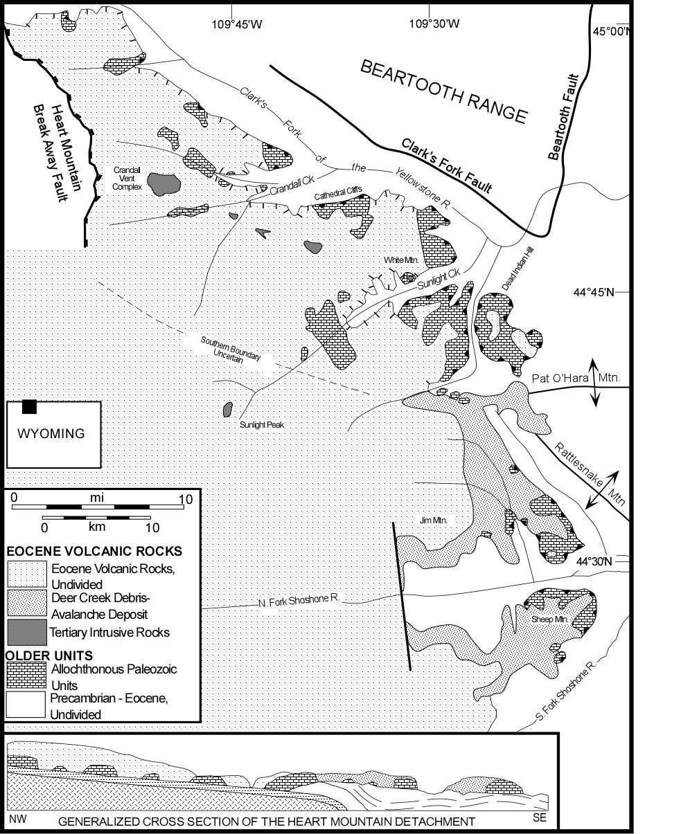

Figure 1. Geologic map and schematic cross section of the Heart Mountain Detachment and surrounding areas (modified from Pierce, 1987, Haugue, 1993, and Malone and others, 1999).

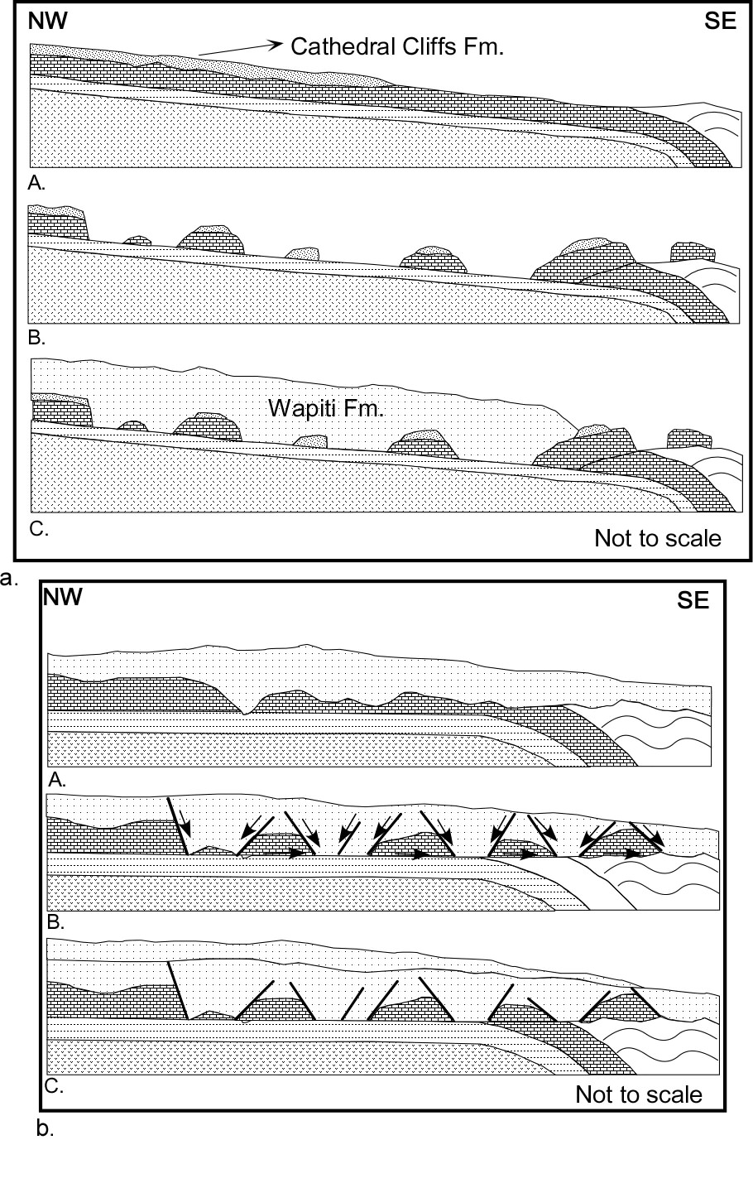
Figure 2. a. Teconic Denudation Model of Heart Mountain Faulting (from Pierce, 1987). Before faulting, Eocene volcanic rocks of the Cathedral Cliffs formation rest upon a dip slope of Palezoic rocks on the flank of the Laramide Beartooth Uplift. A detachment formed along a basal Ordovician bedding plane, and individual, mountain size blocks were catastrophically emplaced along the detachment, and out into the adjacent Big Horn Basin. Immediately after faulting, massive eruptions of Wapiti Formation volcanic rocks buried the disrupted terrain, and preserved its features. Gravity sliding was the dominant emplacement mechanism. b. Continuous Allochthon Model of Heart Mountain Faulting (from Hauge, 1990). Before faulting a thick succession of undivided Eocene volcanic rocks rest upon a dip slope of Paleozoic Rocks on the flank of the Laramide Beartooth Uplift. During building, the volcanic pile became gravitationally unstable, and began to collapse. During this collapse, a detachment formed along a basal Ordovician bedding plane, and volcanic rocks were down-dropped, rotated, and translated into a series of grabens. Thus, the upper plate was comprised of volcanic and Paleozoic rocks, with volcanic rocks comprising most of its volume. This collapse event was gradual, and occurred over as much as 2 million years. After the allochthon stabilized, younger volcanic rocks were deposited on to the disrupted terrain. Gravity spreading was the dominant emplacement mechanism.

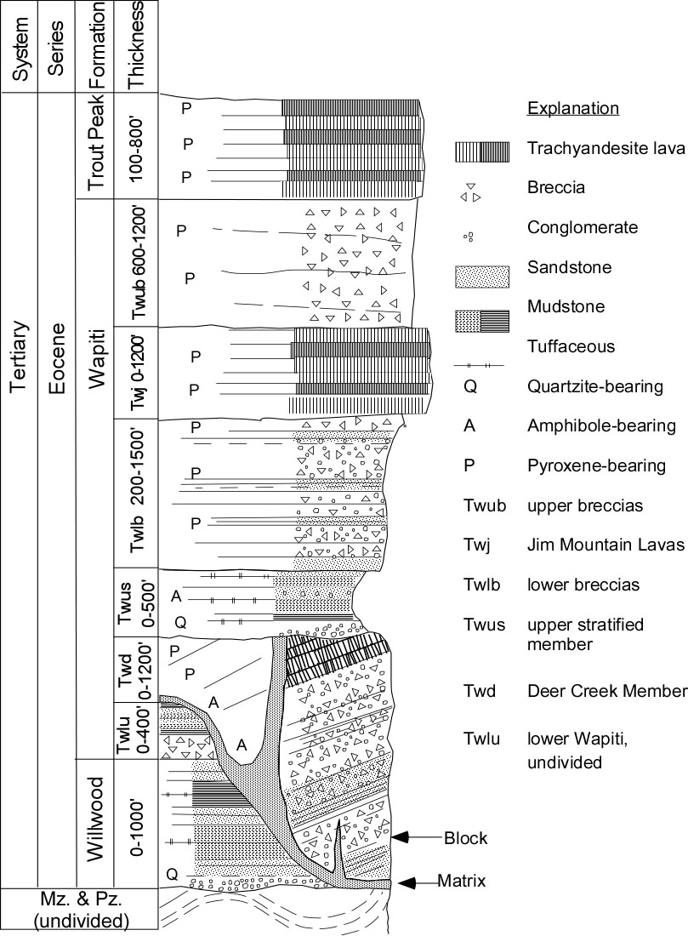

Figure 3. Stragraphic column of Eocene volcanic rocks exposed in the North Fork of the Shoshone River valley (distal areas of the Heart Mountain Detachment; Modified from Malone 1996, and Malone and others 1999).
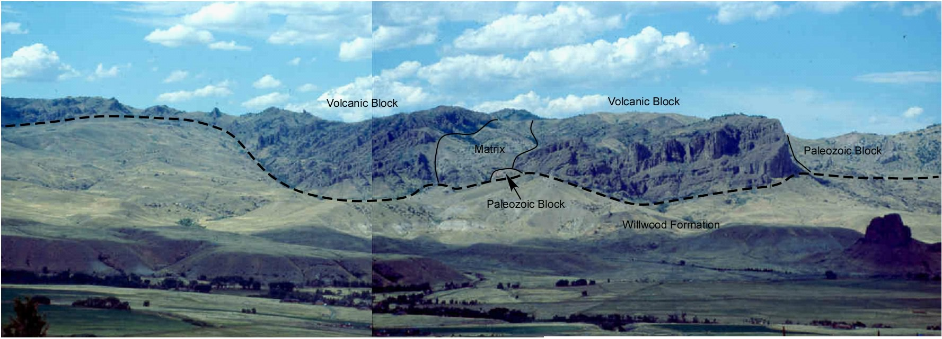

Figure 4a. Panaramic view to the north of the type area of the Deer Creek Member of the Wapiti Formation from the South Fork Shoshone River Valley, about 3 mi (5 km) away. The light-colored, grassy foothills are underlain by the Willwood Formation (Twl) and Cody Shale (Kc). The heavy dashed line is the early middle Eocene land surface with more than 1000 ft (321 m) of relief. In this scene, two blocks (>1 km in diameter) are visible (Twdb). The block to the right (east) consists of about 800 ft of interbedded breccias, sandstones, and conglomerates, and dips about 25° to the north. The two blocks are bounded by a poorly exposed, lighter-colored interval of matrix. Matrix (Twdm) also occurs beneath each block but is too thin to be resolved from this distance. From Malone (1996).

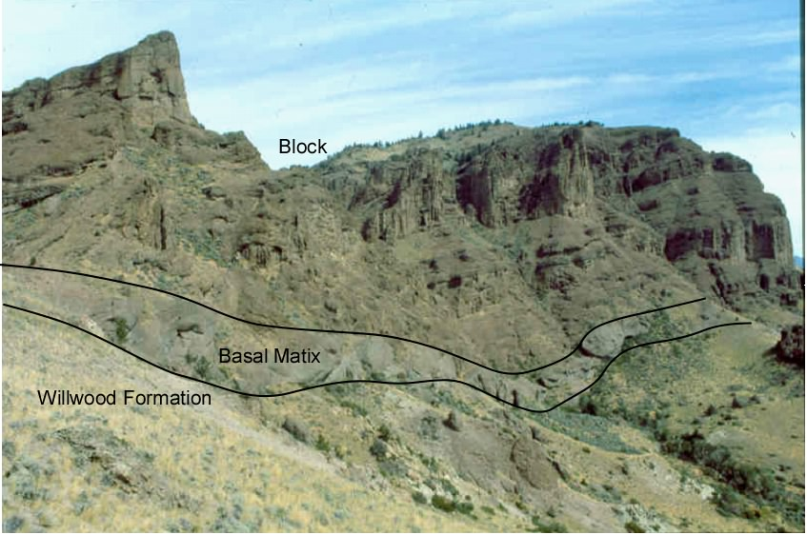

Figure 4b. Closer view to the east of the type area of the Deer Creek Member. This locality is the southerly known limit of the unit, and is more than 25 mi (40 km) from the center of the inferred source area near Sunlight Peak. The steep slopes consist of dark brown breccias, sandstones, and conglomerates within the Deer Creek Member block (Twdb). The beds within the block dip about 30° to the northwest. At the base, a 25 ft (8 m) zone of matrix is present (Twdm). The unit here fills a local Eocene paleotopography with as much as 400 ft (125 m) of relief. From Malone (1996).

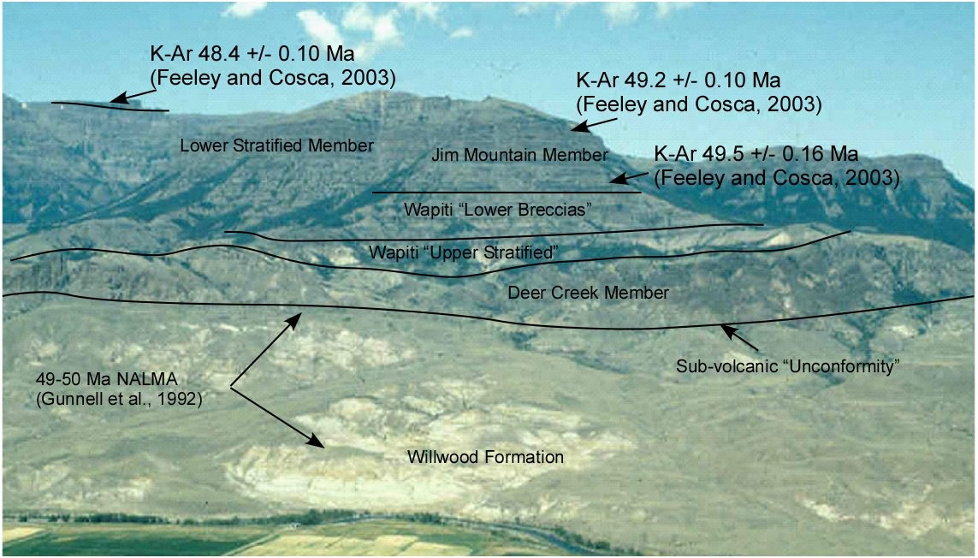

Figure 5. Summary of age control in the North Fork Shoshone River Valley at Jim Mountain.

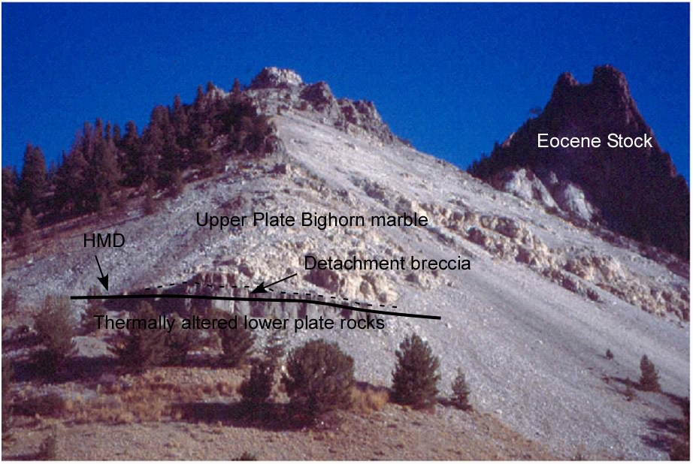
Figure 6a. Exposure of HMD at White Mountain.

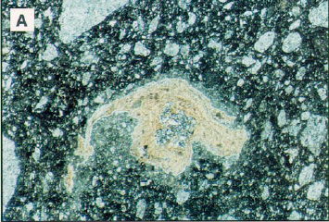

Figure 6b. Delicate volcanic glass shard from White Mountain, field of view, 0.7 cm (from Beutner and Craven, 1996).

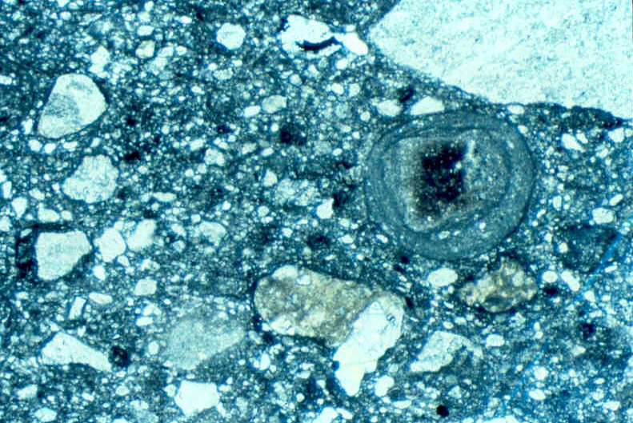

Figure 6c. Accreted grain from White Mountain, field of view, 0.7 cm (from Malone and others, 1999).

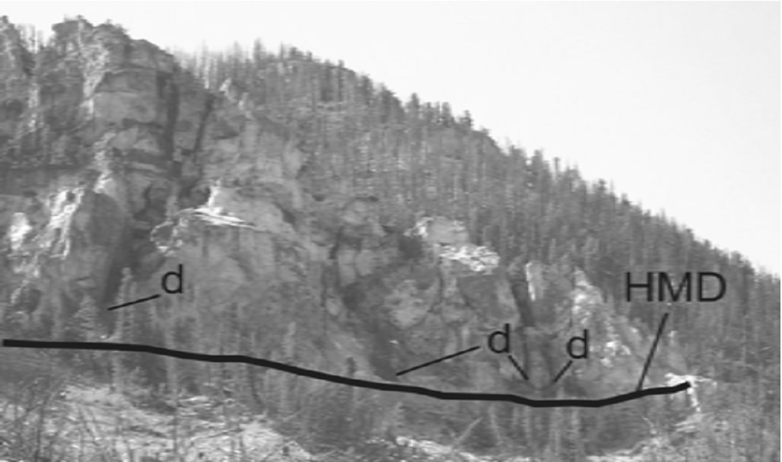

Figure 7. Field relations at the base of Cathedral Cliffs. Eocene igneous dikes terminate along the HMD (from Defrates and others, 2006).
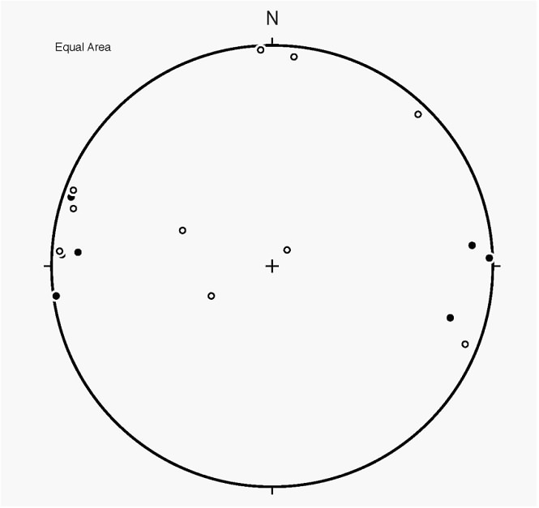

Figure 8. Lower hemisphere projection of pre-detachment, Laramide shortening strains derived from mechanically twinned calcite. Solid circles are footwall limestones which preserve the regional, E-W sub-horizontal shortening whereas allochthonous upper plate limestones (open circles) preserve the same layer-parallel shortening strain but with no pattern (Craddock and others, 2000).

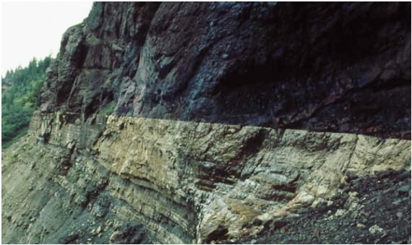

Figure 9. Field relations at Jim Smith Creek. For a detailed description and interpretation of this locality, see Malone and others, 1999.
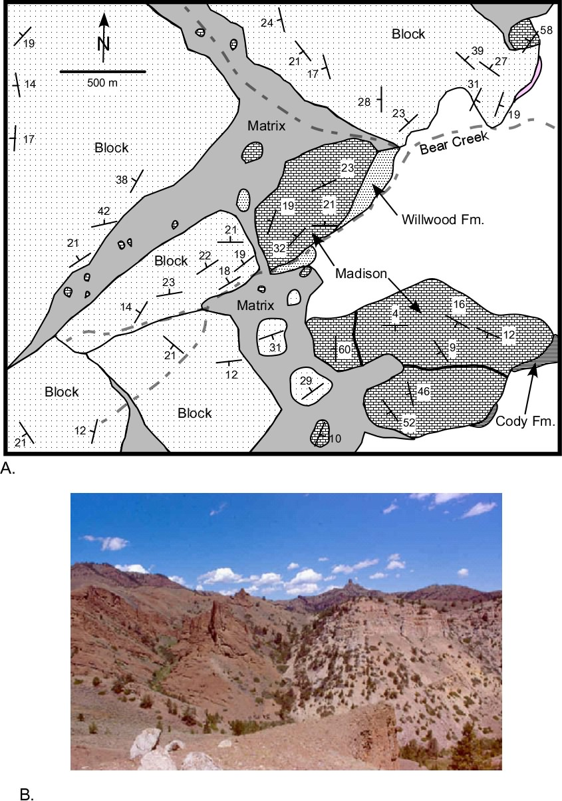

Figure 10. A. Geologic map of the Bear Creek area on the south side of Sheep Mountain in the distal areas of the Detachment. This area is an excellent place to view the relationship between allochthonous Paleozoic and Eocene volcanic rocks. Here, four or five volcanic blocks, each more than 500 m in maximum dimension, rest beside a like number of allochthonous Paleozoic Blocks. Each block has a unique internal structure. Debris-avalanche matrix occurs between the various blocks. Several smaller blocks of volcanic, Paleozoic, and Eocene Willwood Formation occur within the matrix. B. View to the north of the Bear Creek area, illustrating the field relations between allochthonous Paleozoic rocks and Eocene volcanic rocks.

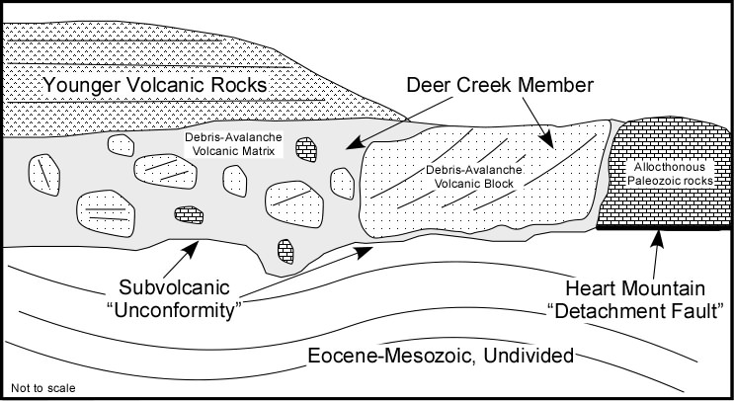

Figure 11. Cartoon of the structural relationship between volcanic and Paleozoic rocks in the distal areas of the HMD. Paleozoic rocks rest upon younger strata, it is easy to consider this contact a detachment fault. However, where Eocene Volcanic rocks overlie the same strata, which is older, a more reasonable interpretation would be an unconformity. As volcanic rocks and Paleozoic rocks comprise a laterally and mappable lithostratigraphic unit within the Absaroka Volcanic succession, and that these rocks are interpreted to be the product of an edifice collapse (i.e. debris-avalanche deposit), we believe that is more appropriate to consider the basal contact everywhere in the distal areas of the HMD an unconformity.

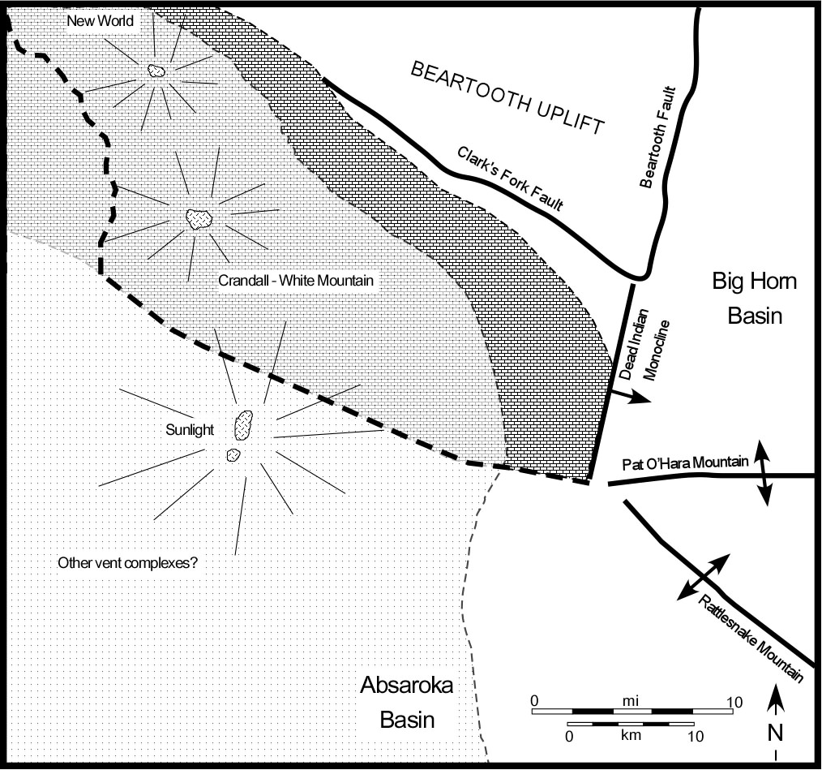

Figure 12. Paleogeographic reconstruction of the HMD area immediately before the emplacement of the upper plate at about 50 Ma (Modified from Malone, 1996).

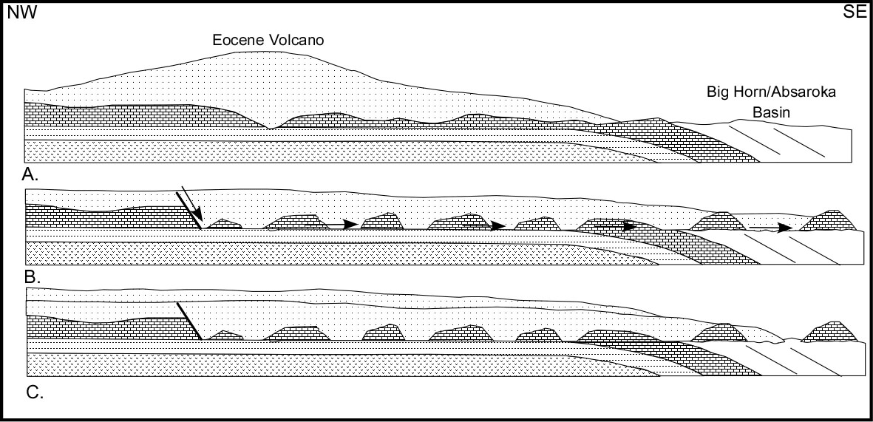

Figure 13. Reconstruction of the edifice collapse that lead to the development of the HMD (Modified from Malone, 1996, Malone and others, 1999, and Beutner and Gerbi, 2005).

